**Lab-02**

**DATA INTEGRITY CONSTRAINTS IMPLEMENTATION**

TASK:

Q1. Create a database UniversityDB and the following tables with constraints:

* Students
* student_id (INTEGER, PRIMARY KEY)
* name (VARCHAR(100), NOT NULL)
* email (VARCHAR(100), UNIQUE)
* department_id (INTEGER, FOREIGN KEY referencing
* Departments(department_id))

Departments

* department_id (INTEGER, PRIMARY KEY)
* department_name (VARCHAR(100), UNIQUE, NOT NULL)

**SQL QUERY:**

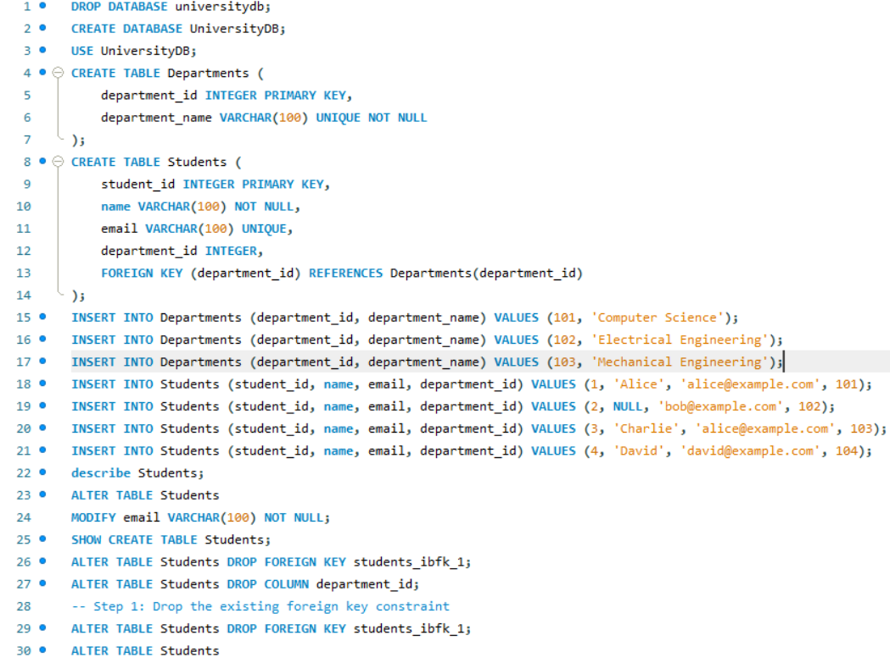

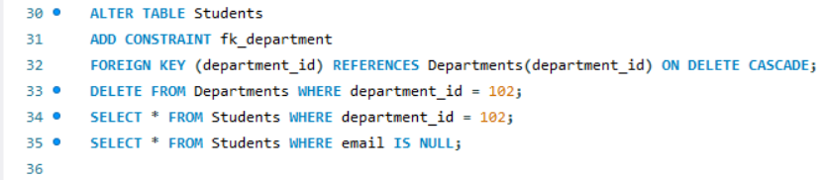

Output:

